1. 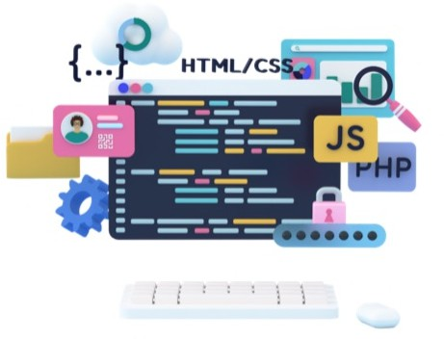language/ support/ cannot/ multiple/ The programming/

paradigms.

1. they/ risks/ this approach?/ discuss/ associated/ the potential/ Could/ with
2. generate/ reports/ on user/ The software/ input./ reposts/ can/ detailed/ based
3. third-party/ The bug/ be caused by/ library./ might/ a conflicting



35

